MICHAEL'S FOUNDATIONS

Career Readiness Foundation

THE CORE IDEA
Discover who you are. Develop what you can become.
Founding concept • October 21, 2026 • Working document

Purpose of this document
Preserve the philosophy, intended learner experience, and emerging areas of exploration before committing to a curriculum, blueprint, technical architecture, or publishing plan. This document is a reference point—not a promise that every idea is final.

At a glance
- Eight proposed learning areas, connected by timeless human principles.
- A discovery-centered approach that values authentic experience, sound judgment, and learner ownership.
- A distinction between enduring principles and changeable tools, examples, and workplace practices.
- A possible companion book: King Solomon’s Wisdom Treasure Chest.

The initial structure
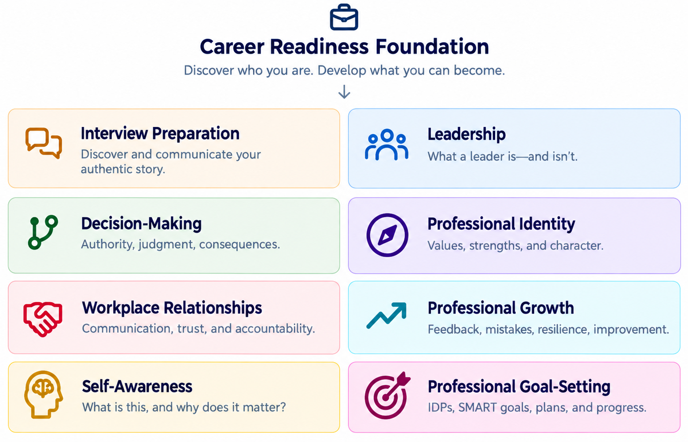
Concept map: eight areas of exploration. The diagram shows possibilities, not a required teaching order.

1. The Founding Principle
You are not going to an interview to convince someone that you could someday become the person they are looking for. You are going to demonstrate the experience, judgment, and character you have already developed.
You do not need to become someone else. You need to learn how to show them who you already are.
This belief inspired the Career Readiness Foundation, but its meaning extends far beyond interviews. People often possess valuable experiences, knowledge, abilities, and personal qualities without recognizing their significance. They may have led without a title, solved difficult problems without naming the judgment involved, or persevered without seeing the resilience demonstrated.
The Foundation will help learners discover, understand, strengthen, and communicate those qualities. Its purpose is not to manufacture a professional identity; it is to reveal and develop an authentic one.

2. The Greater Vision
Getting a job and becoming effective in that job are two different things.
Career readiness includes preparing to enter work and learning to navigate professional life after being hired. It encompasses self-awareness, judgment, communication, leadership, accountability, adaptability, resilience, and continuing growth.
Potential learners include students entering the workforce, Veterans transitioning into civilian careers, career changers, employees strengthening their current performance, and experienced professionals taking on new responsibilities. Professional development is not confined to a hiring process, an annual review, or a promotion.

3. Central Educational Philosophy

Authenticity over performance
Help learners recognize and communicate real value, not imitate a supposedly ideal professional persona.

Judgment over memorization
Develop the ability to examine situations, consider alternatives, explain reasoning, and anticipate consequences—not merely recite preferred answers.

Experience connected to understanding
Use real experiences and plausible situations to illuminate leadership, character, relationships, accountability, and growth.

Growth over perfection
Treat mistakes, constructive feedback, reflection, and second attempts as essential learning opportunities.

Leadership beyond titles
Explore leadership through conduct, initiative, influence, responsibility, and trust—not just rank or job title.

Learner ownership
Guide and challenge without taking possession of a learner’s story, judgment, identity, or conclusions.

Dignity and inclusion
Make room for different backgrounds, career paths, communication styles, and definitions of success. Avoid treating one workplace culture as universal.

4. The Eight Areas of Exploration
These are proposed learning areas, not a finalized sequence. They overlap by design; one authentic experience may reveal lessons in several areas.

4.1 Interview Preparation
Discover and communicate your authentic story.
Recognize the value of experience; connect stories to the requirements of a role; answer thoughtfully; practice and improve without memorizing artificial scripts.

4.2 Leadership
What a leader is—and is not.
Explore influence, authority, responsibility, mentoring, delegation, expectations, trust, and the effects of effective and ineffective leadership.

4.3 Decision-Making
Authority, judgment, consequences.
Examine assumptions, risks, competing priorities, when to consult others, and the difference between being permitted to act and exercising sound judgment.

4.4 Professional Identity
Values, strengths, and character.
Discover what one believes, contributes, values, and demonstrates through conduct. Connect personal experience to an authentic professional identity.

4.5 Workplace Relationships
Communication, trust, and accountability.
Explore listening, disagreement, feedback, collaboration, respect, professional boundaries, and repairing trust when something goes wrong.

4.6 Professional Growth
Feedback, mistakes, resilience, improvement.
Practice learning from setbacks, accepting useful criticism, recognizing limits, seeking expertise, and improving over time.

4.7 Self-Awareness
What is it, and why does it matter?
Explore strengths, weaknesses, values, emotions, habits, assumptions, blind spots, and the difference between intention and impact. Self-awareness is understanding how who you are influences what you do—and how what you do affects others.

4.8 Professional Goal-Setting
Meaningful goals, practical plans, and progress.
Explore the purpose of goals; responsibilities versus improvement versus development; Individual Development Plans (IDPs); SMART and other frameworks; milestones; support; feedback; progress reviews; and adapting plans as circumstances change. The purpose is not to fill out a form but to learn to direct one’s own professional growth.

5. The Learner Experience
Learners should discover rather than merely receive conclusions. Activities may include stories, realistic dilemmas, comparison of alternatives, reflection, decision-making, feedback, revision, and opportunities to apply understanding in new contexts.
Exploratory move | What the learner does
Discover | Explore experience, beliefs, strengths, challenges, and lessons.
Recognize | Identify patterns and what those experiences reveal.
Build | Develop understanding, strategies, decisions, and responses.
Practice | Try approaches, receive feedback, explain choices, and revise.
Use | Apply learning independently in meaningful situations.
This is a conceptual journey, not a new compulsory phase architecture. It will later be reconciled with the established Learn / Build / Practice / Use framework of Michael’s Foundations.
Help learners become better thinkers, not merely better answer-givers.

6. Real Experiences as Learning Opportunities

The Lockheed Martin experience
Perfectionism, feedback, and second chances.
A supervisor challenged a perfectionist approach. The experience prompted reflection on expectations, accepting work that is good enough for its purpose, and the value of second attempts. A possible treasure: sometimes a second attempt produces something better than originally imagined.

The Boeing SBX-1 experience
Authority, consultation, and personnel accountability.
A personnel-accountability solution was implemented within a leader’s authority, but without consulting the Program Director first. Feedback led to a different, approved approach. A possible treasure: having authority to make a decision does not always mean making it alone is the wisest choice.

The Vet Center experience
Listening, dignity, and knowing when to help someone take the next step.
Personal experience seeking support illustrates empathy, trust, appropriate boundaries, and the importance of listening without assuming one must personally solve every problem.
These stories are seeds, not polished case studies. Before publication or instructional use, each should be told in the author’s own voice, with facts checked and sensitive or identifiable details handled appropriately.

7. What Makes This Foundation Different?
It should not become a collection of motivational slogans, generic management advice, or scripted interview answers. Its distinguishing feature is personal discovery through meaningful interaction. Rather than simply defining judgment, let learners face decisions; rather than defining self-awareness, help them notice something about themselves; rather than treating mistakes as failure, allow reflection and a meaningful second attempt.
Feedback should be specific and explain its reasoning. Learners must be able to question feedback, clarify their intent, and defend a thoughtful alternative when the situation permits more than one reasonable answer. The Foundation should distinguish ethical boundaries and factual requirements from situations where judgment legitimately differs.

8. The Timeless Content Principle
The principles should endure. The applications should evolve.
Build for enduring understanding rather than temporary relevance. Self-awareness, integrity, accountability, sound judgment, leadership, communication, reflection, and growth should still be worth teaching a decade from now. Examples, technologies, organizational forms, hiring conventions, and terminology can be refreshed without rebuilding the instructional core.
Enduring principle | Replaceable application
Consult others when a decision affects them. | Specific approval chains, collaboration tools, or company procedures.
Reliable accountability depends on accurate information. | Badge exchanges, databases, or future access systems.
Meaningful goals need purpose, action, and review. | IDP templates, SMART worksheets, or annual review software.
Authentic communication demonstrates experience. | Interview platforms, résumé conventions, or application formats.
Quality test: Will this idea still matter in ten years? Is it sound and worth teaching? Can examples change without undermining the lesson? Does understanding transfer to unfamiliar situations? Revisit even “timeless” principles when stronger evidence or ethical understanding warrants revision.

9. Professional Goal-Setting: A Deeper Concept
Creating meaningful professional goals is harder than completing a form. An employee must assess the present, identify worthwhile growth, make tradeoffs, plan actions, and evaluate results. The Foundation should teach this thinking before introducing a framework such as SMART or an employer-specific IDP.

Distinctions learners should understand
Type | Example
Job responsibility | Complete assigned work accurately and on time.
Performance goal | Improve a defined aspect of work or achieve a particular result.
Development goal | Build a skill, ability, knowledge base, or experience for current or future work.

Questions worth exploring
- Where am I now, and what evidence supports my self-assessment?
- What would be worth accomplishing—and why?
- What can I influence, and what depends on other people or circumstances?
- What steps, resources, support, and time will I need?
- How will I recognize progress and know whether the goal was achieved?
- What will I do if circumstances change or my first approach does not work?
Professional growth does not always mean promotion. It may mean becoming more effective, dependable, thoughtful, skilled, or supportive in one’s present role. A plan is a living guide, not a document to forget until the next annual review.
The goal is not to teach someone to complete an IDP. The goal is to teach someone to thoughtfully direct their own professional growth.

10. How the Areas Connect
The eight areas should be distinguishable but not isolated. Self-awareness informs goals and professional identity. Judgment shapes leadership and relationships. Feedback fuels growth. Authentic stories support interviews, while interviews themselves can reveal opportunities for development. These connections are a design opportunity, not a mandate to force every area into every lesson.
A future activity might begin with a real dilemma, invite a decision, surface assumptions, examine its effect on others, and finish with a personal goal or reflection. The same experience could be revisited from a different perspective later.

11. What Meaningful Learning Would Look Like
The Foundation should look for evidence of understanding rather than a single “correct” phrase. Learners might explain why they chose an action, recognize a tradeoff, revise a plan after feedback, tell an authentic story more clearly, or apply a principle in a new situation.
- Reflection that identifies a genuine insight, not merely agreement with the lesson.
- Reasoned decisions that acknowledge consequences and alternative approaches.
- Constructive response to feedback, including justified disagreement.
- Transfer: applying a principle to a different workplace or life situation.
- Ownership: expressing conclusions and goals in the learner’s own voice.
Formal assessments, scoring, privacy safeguards, and technical implementation are not decided here. Personal reflections should not be treated as diagnostic judgments about personality or mental health.

12. The Long-Term Objective
Success is not measured solely by hiring, promotion, or interview performance. It may be a learner recognizing an overlooked strength, responding thoughtfully to criticism, improving a decision, seeking help appropriately, repairing a relationship, setting a meaningful goal, or discovering new capacity for growth.
Discover who you are. Understand what you bring. Develop what you can become. Achieve what you once thought was impossible!

13. Companion Book Concept — King Solomon’s Wisdom Treasure Chest
A potential companion book could collect authentic personal and professional stories, the discoveries that followed, and enduring lessons readers can question and apply. The book and Foundation share a philosophy but need not share the same structure: the book tells and reflects; the Foundation invites learners to experience and decide.
Possible recurring feature | Purpose
The Story | What happened, including uncertainty and imperfect decisions.
The Discovery | What changed in the author’s understanding.
The Treasure | The principle worth carrying forward.
The Reader’s Turn | A question or dilemma inviting the reader’s own judgment.
The narrator should not be portrayed as someone who always knew the answer. Some of the most valuable lessons came from being mistaken, receiving difficult feedback, or recognizing someone else’s better idea. “King Solomon” is a playful working frame, not a claim of infallibility.

14. Open Questions — Preserved for Later
- Which audiences should the first version serve, and what differences in examples or language will they need?
- How will the eight areas be sequenced or connected without losing learner choice?
- Which personal stories can be shared responsibly, and what details need confirmation or anonymization?
- What does meaningful feedback look like when multiple responses are defensible?
- How can the established Michael’s Foundations components support this content without dictating the pedagogy?
- What should remain Foundation content, and what belongs in the companion book?

15. Development Boundaries and Next Steps
This is an Idea Sphere / founding-concept document. It does not authorize a complete curriculum, technical build, fixed assessment model, or book outline. New ideas may be appended, challenged, merged, or retired. Preserve the principle before selecting an activity, and preserve the learner’s independence before designing feedback.
When development begins, a sensible next step will be to choose one small concept, describe the learner’s experience, and test whether it truly teaches an enduring principle. That decision can wait.

The Heart of the Foundation
People often possess more experience, ability, wisdom, and potential than they recognize.
Our responsibility as educators is not merely to tell learners what they should become. It is to help them discover what they already possess, understand what they can improve, and develop the confidence and judgment to move forward.
FOUNDING CONCEPT • OPEN TO REFINEMENT

